Báo cáo tuần 6

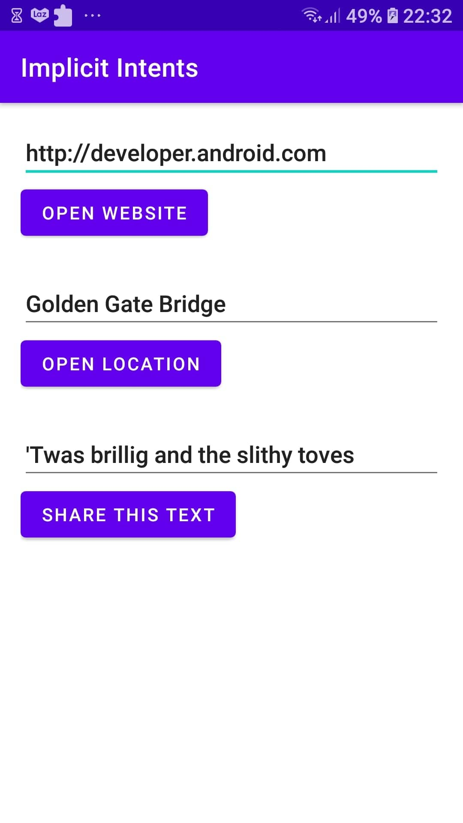



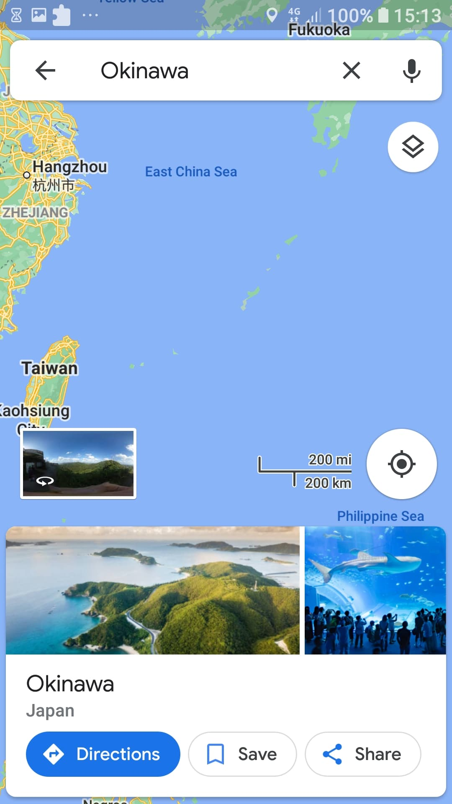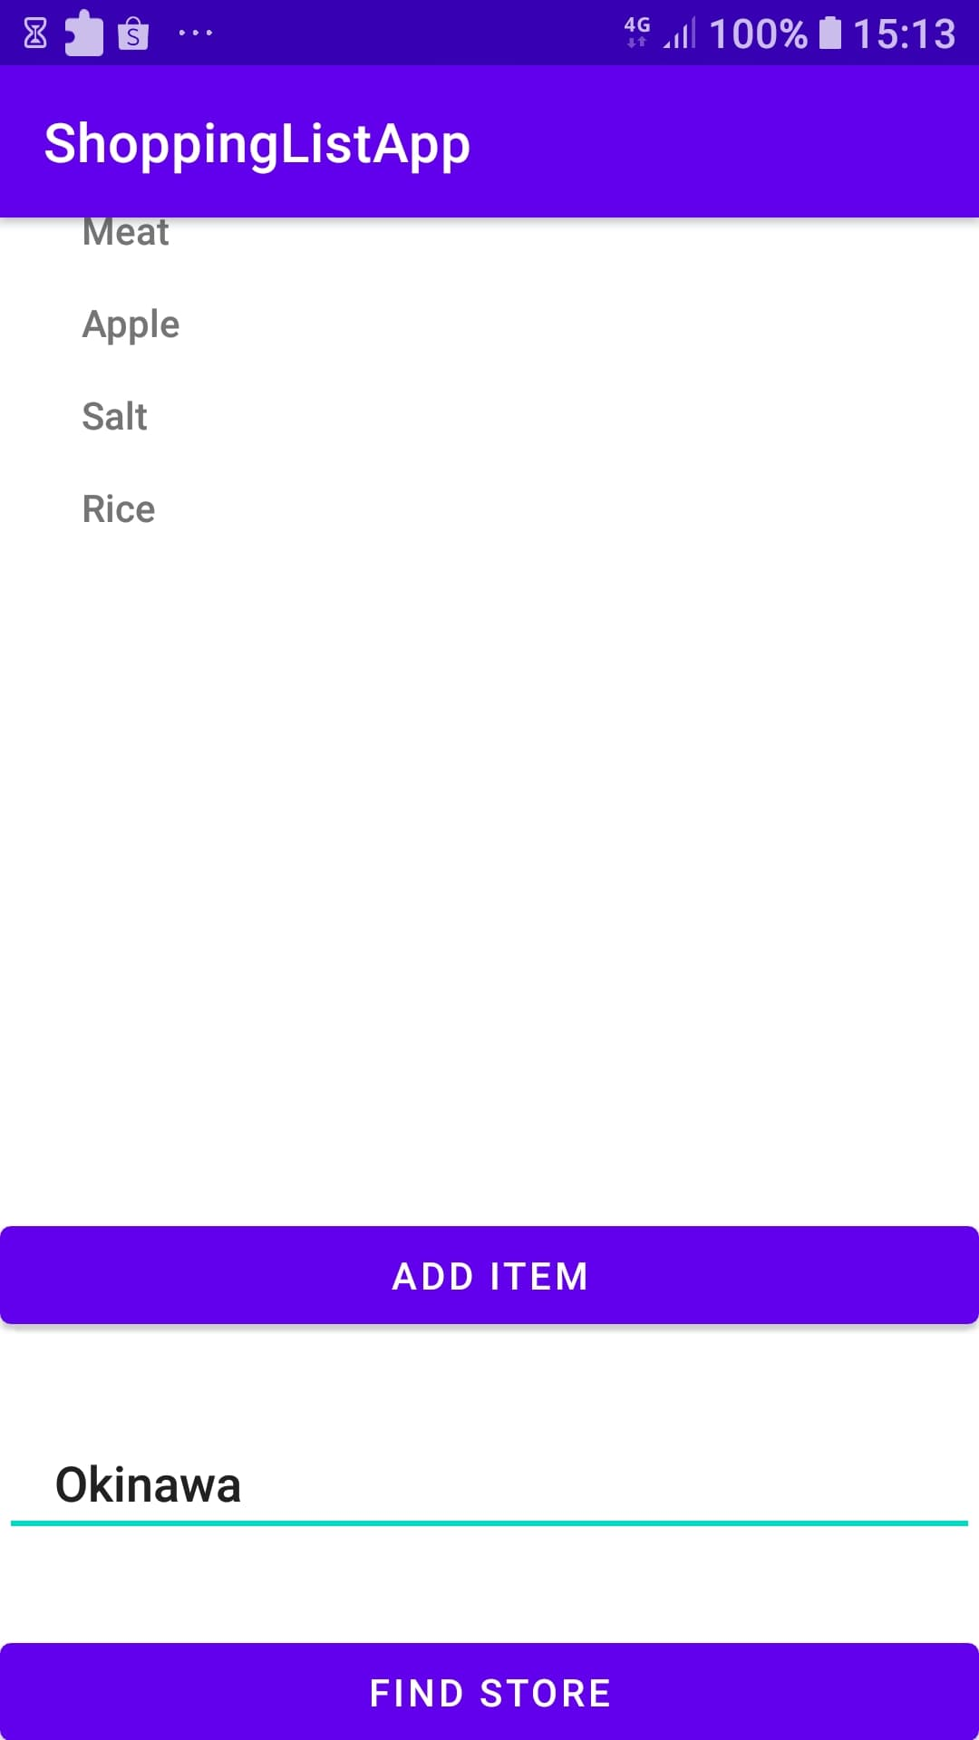

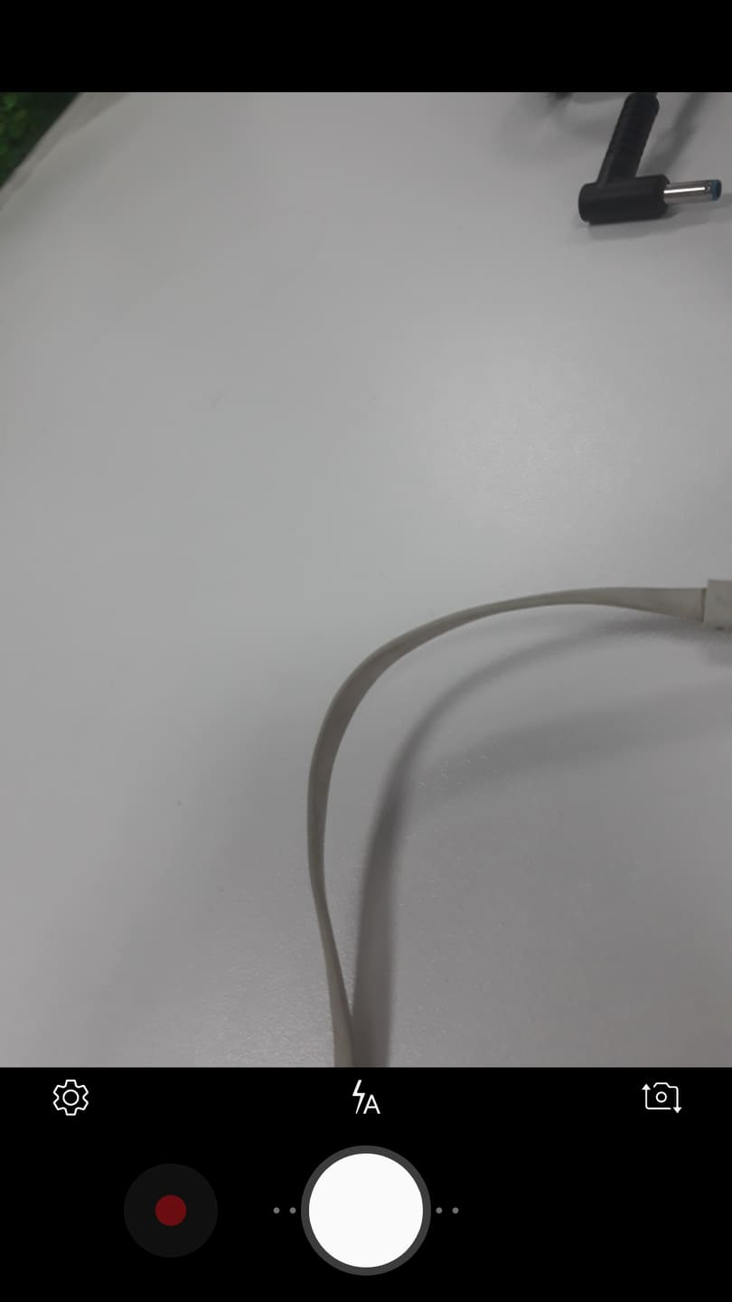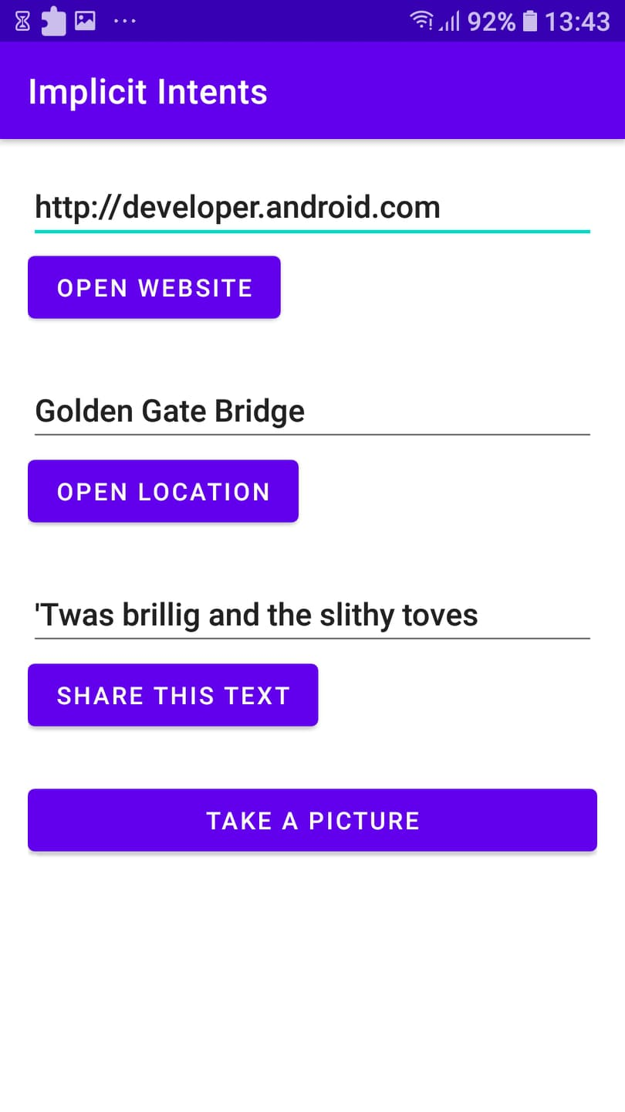

* Which constructor method do you use to create an implicit Intent to launch a camera app: new Intent(String action)
* When you create an implicit Intent object, which of the following is true?: All of the above.
* Which Intent action do you use to take a picture with a camera app?: Intent takePicture = new Intent(MediaStore.ACTION_IMAGE_CAPTURE);

Bài 2:

